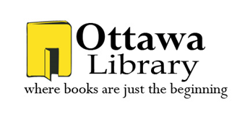 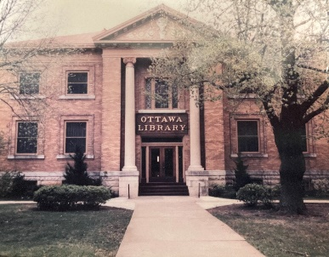

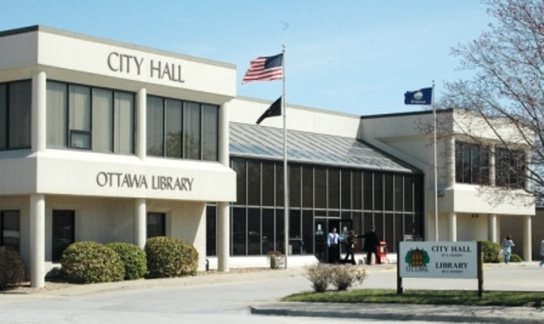

1996 to Current

29 years

1903 – 1996

93 Years

Ottawa Library Strategic Plan 2025 and Beyond Beyond

The Future 3/1/2025

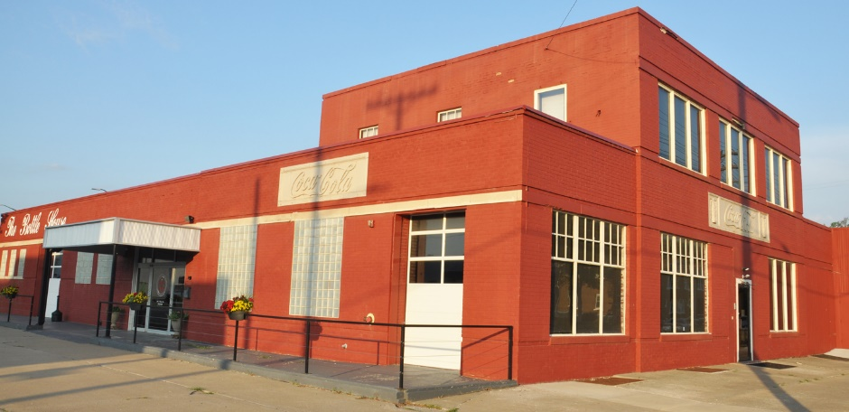 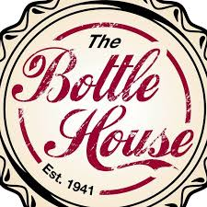

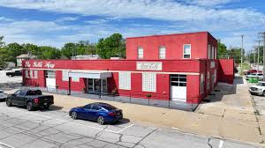 

**Executive Summary**

Ottawa Library has been in existence since March 1872 when fifteen members of the Ladies’ Reading Club decided to establish their club “on a boarder basis” and nine of those ladies paid $1.00 in dues. It is an honor to carry on their legacy. Ottawa Library proudly serves a population of approximately 12,500 people in the town of Ottawa, Kansas.

The Ottawa Library staff and Board of Trustees are committed to providing our community with materials, services, public spaces, programming, activities, and events that will bring value and education to their individual and their family’s lives. Libraries have always been on the cusp of the great transformation of our world changes and continue to evolve to meet those changes and the desires of our communities.

Mission

Ottawa Library is a community library that links everyone to free educational, informational, and entertainment resources through responsive, quality service that supports lifelong learning.

Our Values

The Ottawa Library answers to many stakeholders, and our goal is to satisfy their expectations. These stakeholders include the library board, the city, the schools, and - most importantly - the community.

* **Equality of access**
  + The library strives to provide access to every patron and community member that enters the library regardless of ethnicity, sex, age, or other factors. The library believes in and supports intellectual freedom as described by the American Library Association.
* **Well trained and attentive staff**
  + The library will always do its best to have the most knowledgeable and supportive staff. Ottawa Library wants librarians, paraprofessionals, and volunteers who not only care about the library, but who also care about the community. It is a further priority of the library to keep the staff updated on the training and information necessary that enables them to give patrons the access to information they need, when they need it.

#### “The most important asset of any library goes home at night – the library staff.” -Timothy Healy

* **Creating a place that is centered on the community**
  + Ottawa Library not only wants to provide equality of access and a staff of knowledgeable professionals, but also to create a place of community unity where the people in the community enjoy gathering. The library additionally wants to meet the educational, informational, and entertainment needs of the community as a whole and will strive to do so by listening and answering to community members.
* **Variety of valuable resources**
  + The library wants to provide as many diverse and accessible resources as possible. As libraries change, it will be especially important for the library to provide not only current print materials, but also resources that connect the patrons and community with materials and information that are outside the physical walls of the library.
* **Privacy and confidentiality are rights**
* The library staff safeguard patrons’ right to request and obtain information in confidence.
* **Quality service**
* The library strives to deliver the highest quality services possible.

Organizational Performance

In creating this strategic plan, we reviewed what the library currently offers and discovered we have a solid foundation on which to build. Ottawa Library has a well-educated staff that truly cares about our patrons and community. Benefiting our continued successes at the library are employee longevity and high morale as well as the many, varied programs for children, teens, and adults. Our materials’ collection, genealogy, Kansas history, public computers, and wireless access are all highly regarded by our patrons and community.

Future Vision

*“Knowledge emerges only through invention and re-invention, through the restless, impatient, continuing, hopeful inquiry human beings pursue in the world, with the world, and with each other.” –* Paulo Freire

Ottawa Library strives to be a reliable destination for patrons for the latest technology tools and services. Through outreach, we will be addressing the needs of the community; by forming partnerships, we will be building relationships and connecting with community members. We envision a library that is willing and able to transform to meet the needs of our patrons and community.

Strategic Initiatives

* **Improved Library Services**

To remain relevant to our community, we must continually analyze and provide services to our community that are valuable and help improve and strengthen the lives of our community members.

* **Engage, Enrich, and Encourage**

Teamwork as a staff will result in teamwork for our patrons. We must engage with staff, patrons and community leaders to continue to enrich lives and encourage success.

* **Broaden Community Outreach**

We accept a large civic role in our community, we must continue to go beyond the walls of the library to provide additional services. Though we will continue to provide the traditional needs, we must provide outreach to the wider community to become a destination library and a more vibrant public place.

* **New Library Building**

In October of 1903, the Ottawa Library building at 5th and Main Street was dedicated. After 93 years, we moved to our current location, 105 S. Hickory Street, in September of 1996. Most of our square footage is located in the basement of our building. A building with more program space, meeting room space, windows, outdoor green space, and FOL Book Store space has been a staff and community request/need for some time.

* + 2019 we purchased land at 228 W. 15th Street, Ottawa, Kansas
  + 2020 building design in process with Sabatini Architects, Lawrence, KS
  + 2020 preliminary building design
  + 2020-2021 COVID-19
  + 2021 Pre-campaign assessment with Swanson House
  + 2022 Continued campaign council with Swanson House
    - Bond issue and private funds planning
  + 2025 Purchase 202 South Walnut, Ottawa, KS (The Bottle House)
  + 2025 List 228 W 15th Street, Ottawa, Kansas
  + 2025 - 2027 Capital Campaign & Bond issue presentation
  + 2025 - 2027 Capital Campaign, finalize building plans, election
  + 2027 - 2028 Break ground and build new building

**Annually**

* Review Strategic Plan
* Review/update logo
* Review Mission Statement
* Create/Review Vision Statement

Reviewed and approved: December 16, 2024