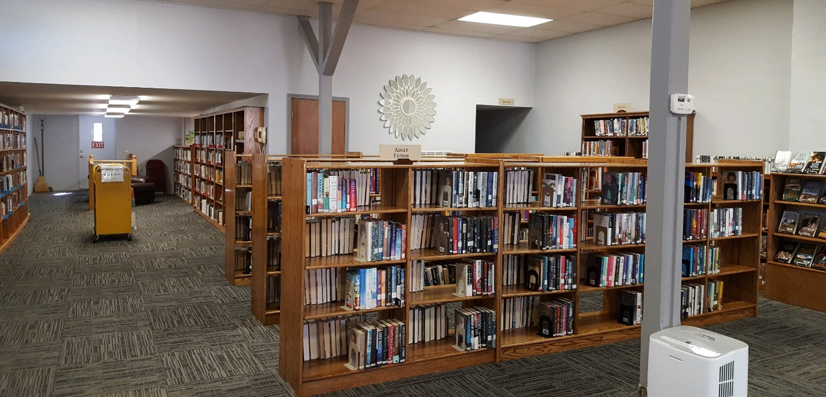

CENTRALIA COMMUNITY LIBRARY

520 4TH STREET

CENTRALIA, KS 66415

785-857-3331

Strategic Planning for 2025-2028

**Vision Statement**

The Centralia Community Library, a tax-supported community resource, will provide informational, educational services, materials, and programs to users of all ages.

**Mission Statement**

The mission of the Centralia Community Library is to provide diverse cultural opportunities for reading, learning, and entertainment to all citizens within its service area.

2025-2028 Strategic Plan

**GOAL #1: Effectively market the library’s products and services**.

Objective 1.1 – Enhance the awareness and presence of the Centralia Library within its own community.

Action Steps:

1. Support and sponsor city and community events: Card parties, coffee groups, and Trunk or Treat.

Timeline: Year round

Responsible Parties: Library Director and Library Board

1. Partner with the local school and nursing home to share books and materials.

Timeline: Year round

Responsible Parties: Library Director and Library Board

Objective 1.2 – Increase the use of media outlets to advertise library opportunities, resources, and activities.

Action Steps:

1. Work with NEKLS to maintain our own library website.

Timeline: Ongoing

Responsible Party: Library Director

1. Use social networking such as Facebook to promote opportunities, resources and activities provided through the library.

Timeline: Ongoing

Responsible Party: Library Director

1. Use city, post office, bank and grocery store bulletin boards to advertise opportunities, resources, and activities for the Library.

Timeline: Ongoing

Responsible Party: Library Director

Objective 1.3 – Continue to provide and promote activities to engage community involvement.

Action Steps:

1. Maintain regular events for the community i.e: coffee groups, card groups, Trunk or Treat.

Timeline: Present - Ongoing

Responsible Parties: Library Director and Library Board

1. Join with other groups for an activity i.e: Night at the North Pole and 4th Of July parade.

Time line: Present – Ongoing

Responsible Parties: Library Director and Library Board

**Goal #2 Expand outreach to include diverse, updated, and innovative opportunities and resources.**

Objective 2.1 – Create a library atmosphere that will optimize the utility of the existing space and improve community interaction within it.

Action Steps:

1. Discuss and prioritize ways to improve operation and physical appearance of library.

Timeline: Ongoing

Responsible Parties: Library Director, Library Board & other

2.Investigate new technologies to improve library systems and add

resources i.e.: Techsoup, Flipster, and Zoom.

Timeline: Ongoing

Responsible Parties: Library Director and Library Board

**Goal #3: Increase and secure financial sources and non-financial resources.**

Objective 3.1 – Efficiently utilize volunteers with expertise or resources.

Action Steps:

1. Establish and maintain relationships with community members and patrons of the library to help the library implement/improve programs, maintain building and other improvements as needed.

Timeline: Present – ongoing

Responsible Parties: Library Director and Library Board

Objective 3.2 – Hold fundraisers to ascertain monetary resources as needed.

Action Steps:

1. Participate in the Annual Library Giving Day each April and Giving Tuesday in November or December with assistance from NEKLS.

Timeline: Present – Ongoing

Responsible Parties: Library Director and Library Board

1. Develop a plan for ongoing fundraising activities.

Timeline: Present – Ongoing

Responsible Parties: Library Director and Library Board

Objective 3.3 – Actively research and pursue local, state and federal grant opportunities.

Action Steps:

1. Establish needs and priorities of library and then research and review grant opportunities.

Timeline: Present – Ongoing

Responsible Parties: Library Director and Library Board

**Goal #4: Conduct and provide relevant, timely and informative evaluation**

Objective 4.1 – Evaluate the status of current programs, services, and resources offered by the library.

Action Steps:

1. Continue to evaluate and develop the library’s collection

Timeline: Present – Ongoing

Responsible Party: Library Director

1. Seek input from patrons and community members through conversation, comments, and social media

Timeline: Present – Ongoing

Responsible Party: Library Director

1. Continue to research, participate and evaluate library service agreements with various libraries and regional and statewide organizations to increase easy access to materials not in the library’s collection.

Timeline: Present – Ongoing

Responsible Party: Library Director

Objective 4.2 – Review all library plans (Strategic Plan and Technology Plan annually.

Action Steps:

1. Create a formal procedure to establish committees and timelines

2. Hold annual meetings with each committee that has a plan in place.

Timeline: Present – Ongoing

Responsible Parties: Library Director and Committee Members

3 Review plans annually and determine appropriate revisions to goals,

Objectives, action steps, and timeline.

Timeline: Present – Ongoing

Responsible Parties: Library Director & Committee Members

1. Provide updated changes and revisions to board for approval.

Timeline: Present – Ongoing

Responsible Parties: Library Director

Objective 4.3 – Evaluate and invest in staff and volunteers

Action Steps:

1. Continue to conduct an annual evaluation on any staff members.

Timeline: November of each year

Responsible Parties: Library Director

1. Conduct an annual evaluation of the library director.

Timeline: November of each year

Responsible Parties: Library Board

1. Evaluate volunteers and offer orientation, training, tools, and resources when feasible.

Timeline: Present – Ongoing

Responsible Parties: Library Director and Library Board

Library Board Approved 12/18/2024

Sent to Mike McDonald at NEKLS by email on 12/20/2024