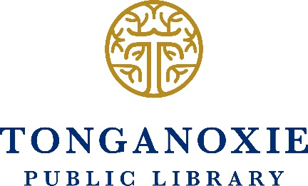

2019-2022 Tonganoxie Public Library Strategic Plan

The Tonganoxie Public Library enhances the lives of our patrons by strengthening the core of our community.

- We want to assist community members in leading healthy and happy lives. We provide programming that enhances literacy and improves core life skills, including technological proficiency, financial well-being and personal wellness.

- We aspire to be a trusted partner in education, providing experiences that complement area curricula and diverse individual learning styles. We provide assistance to our patrons so they might become confident and discerning digital consumers.

- We partner with area businesses and nonprofits to help them thrive in our community. We provide opportunities to community members seeking workforce training and help our business community share our unique and technology-friendly resources, programming and spaces.
- We reflect our diverse community with a wide variety of collections and programs. We place special emphasis on local needs and aggressively promote the library to all segments of our community.

- The Tonganoxie Public Library will work to eliminate barriers to the pursuit of personal enrichment. We provide classes and materials to empower patrons to use the latest technology, keeping our community at the forefront of print and electronic information access.

- We will aspire to be a library without walls, providing access to individuals beyond the physical institution. We are developing pop-up libraries and partnerships to address the needs of place-bound individuals and communities and find ways to bring the library to patrons.

