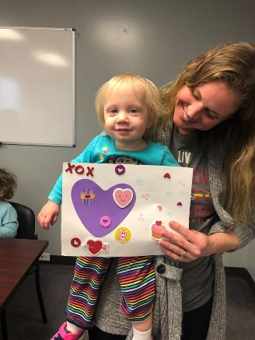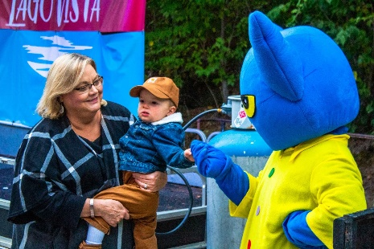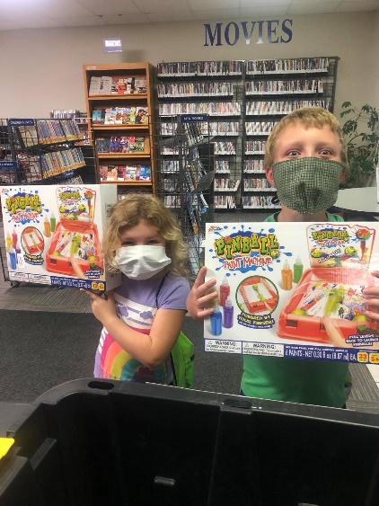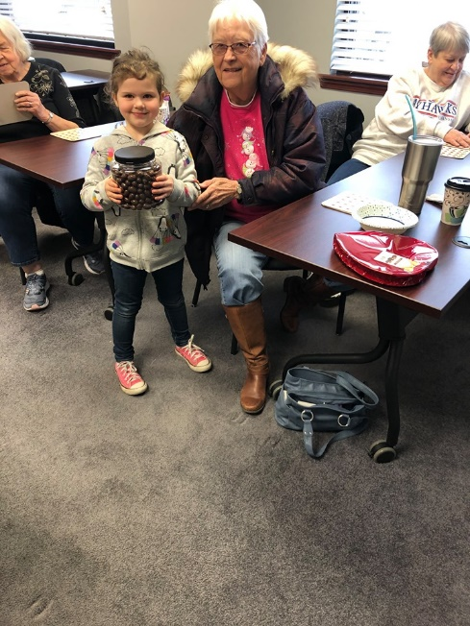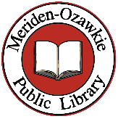

189 Children, 54 Adults and 22 Teens

Signed up for the 2020 Summer Reading Program.

Meriden-Ozawkie Public Library

Annual Report 2020

Circulation of Adult Materials 12,231.

Circulation of Children’s Materials 12,032.

Circulation of DVDs and Blu-Rays 7,138.

Items loaned to other libraries 5,578.

Items borrowed from other libraries 5,049.

Total Collection of Electronic Resources Available to Patrons 976,659.

The total circulation of Electronic Materials 27,074.

3,120 Website Visits.

19,554 Wireless Sessions.

2,199 Uses of Public Computers.

221 Wi-Fi Hotspot Circulations.

The library was open 2,198 hours.

There were 11,545 Visits to the library in 2020.

1,808 people have a card at our library.

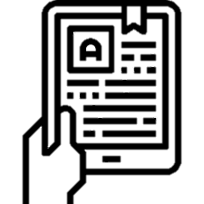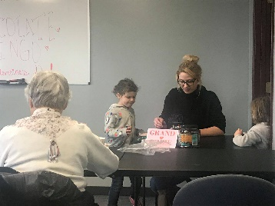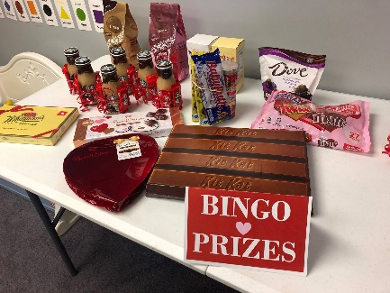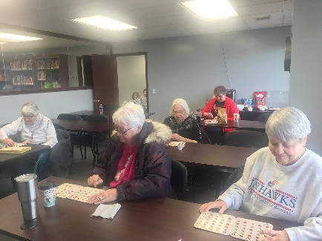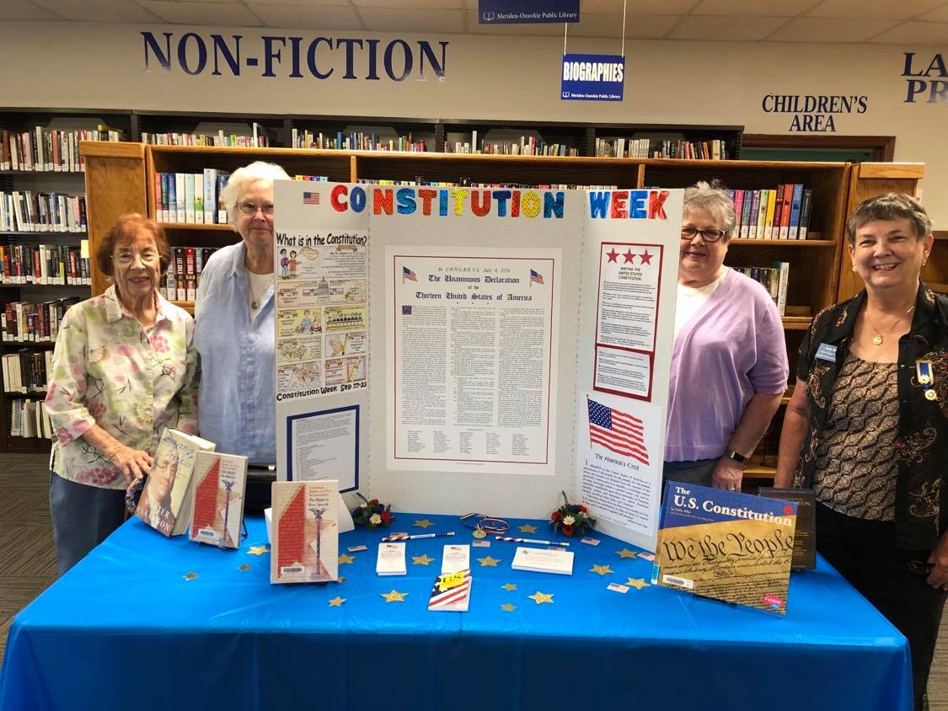v

Chocolate Bingo

8 people came to the Chocolate Bingo for Valentine’s Day.

The Daughters of the American Revolution put up a display for Constitution Week

Cards

43 people came to play cards at the library.

Book Club

51 People attended Book Club over 2020.

Electronic Resources Class

14 teens and 3 adults from the high school visited the library. They all received their own library cards and were taught how to use the KS State library, Hoopla, and Overdrive/Libby.

Teen Programming

Adult Programs

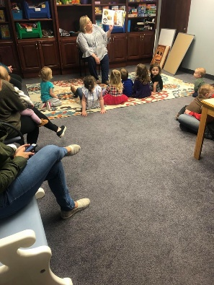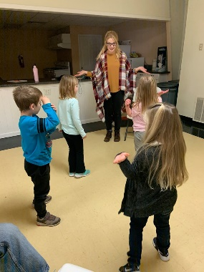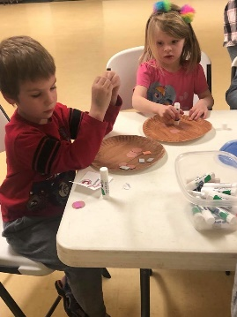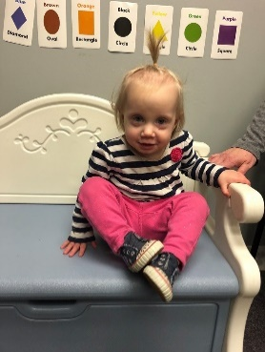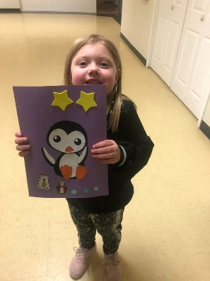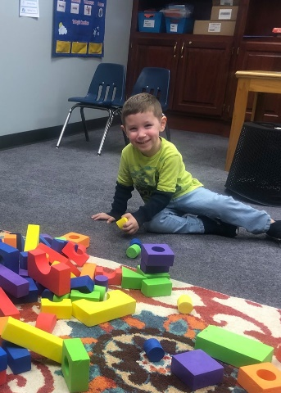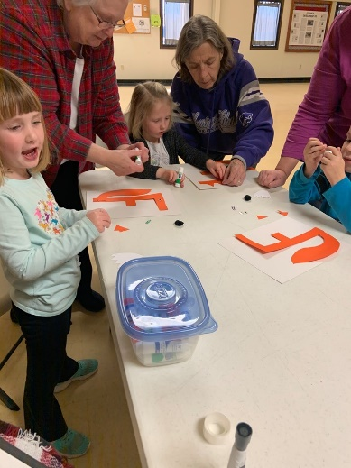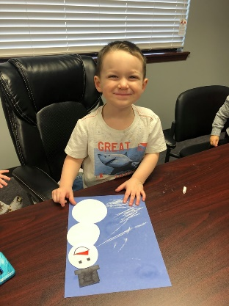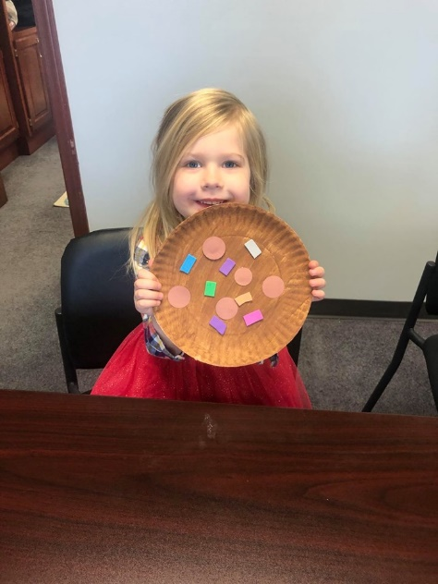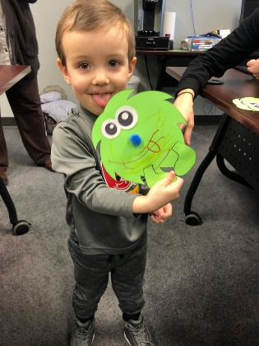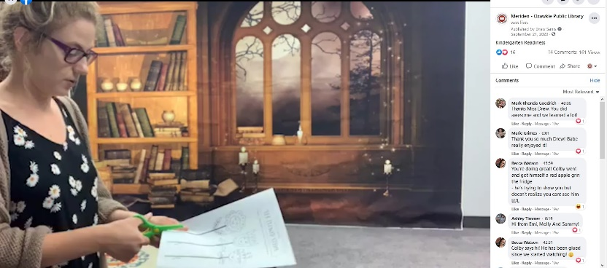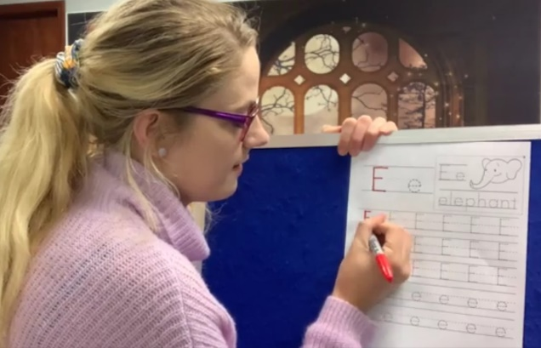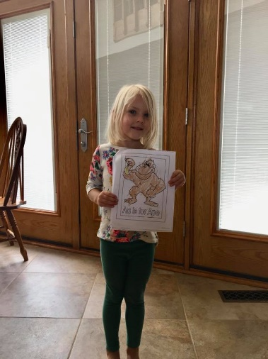

Children’s Programming

Outreach

The library visited Crèche Academy 11 times and the school 18 times.

800 Children were reached.

StoryTime

96 Adults and 132 Children came to in-person StoryTime.

We had 43 Virtual StoryTimes with 3442 views overall.

Kansas Reads to Preschoolers

We had 2 in-person Programs & 2 Recorded Programs.

We gave out a copy of Groovy Joe Ice Cream and Dinosaurs, a craft, and an ice cream cup.

Kindergarten Readiness

15 Children enrolled in the program. When they signed up, Children received personalized worksheets, a kit with school supplies, and a copy of “Chicka Chicka Boom Boom” by Bill Martin Jr.

We held 13 Virtual Programs in 2020.

Every week the library provided new worksheets and crafts.

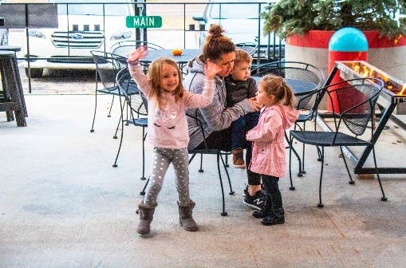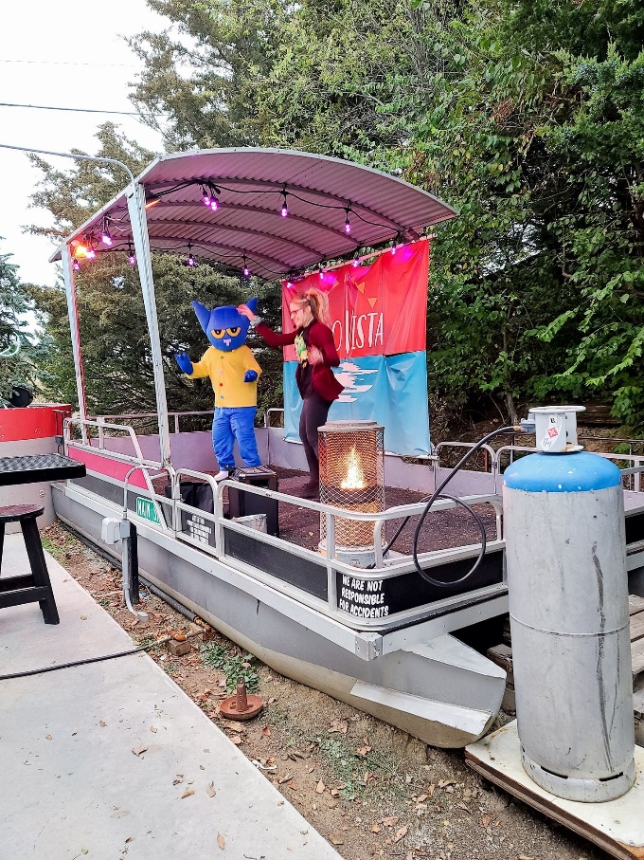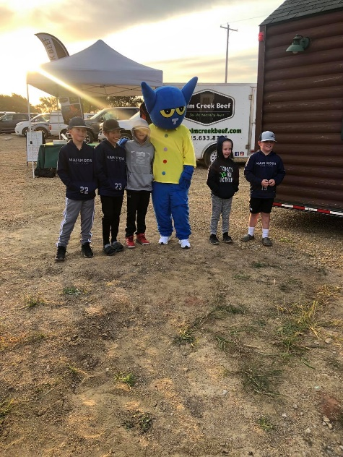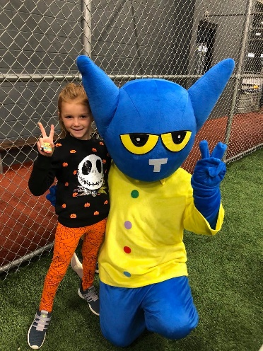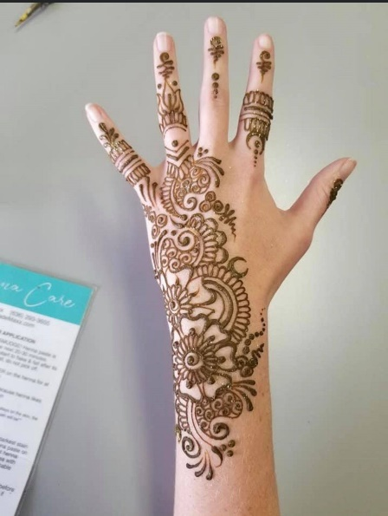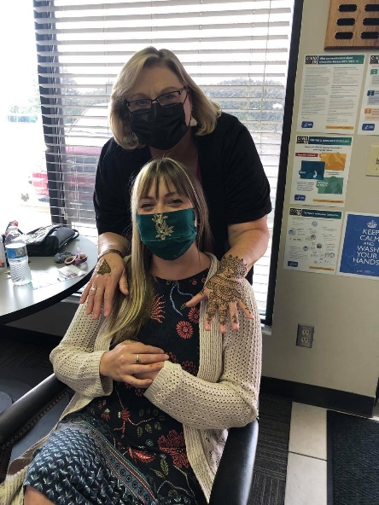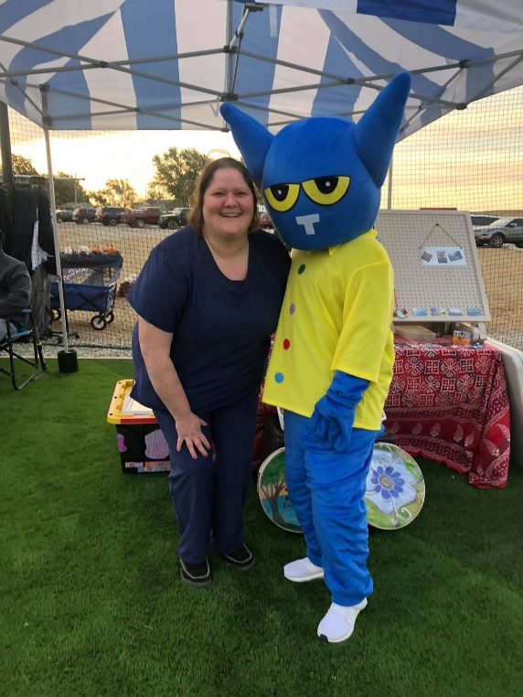

Family Programs

Henna at the Library

A henna artist visited the library. 12 people got unique henna tattoos!

Woolly Farms Fall Festival

Pete the Cat and his library friends attended the fall festival at Woolly Farms. Over 300 people attended this event.

Pete the Cat at Lago Vista

Pete celebrated Halloween at a fundraiser put on by Lago Vista.

Summer Reading 2020: Imagine Your Story

June 1st – August 29th

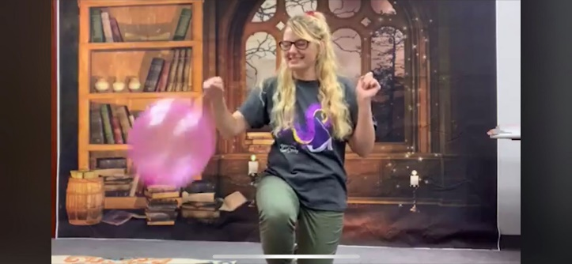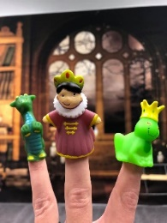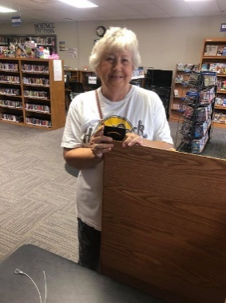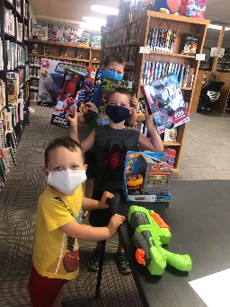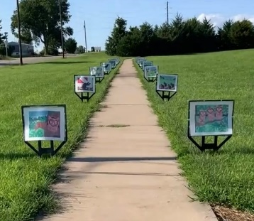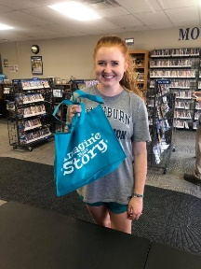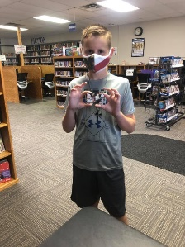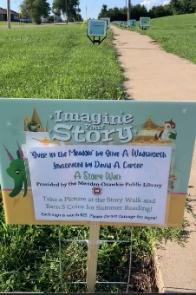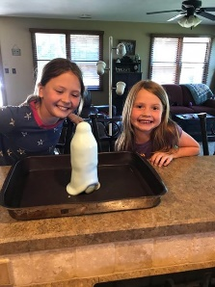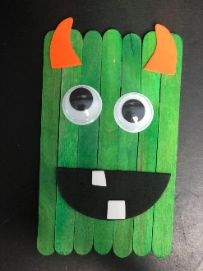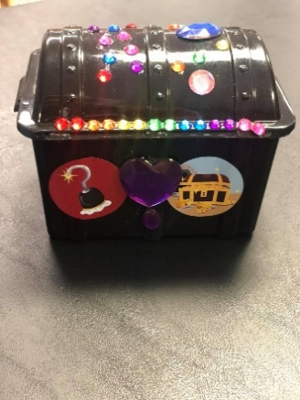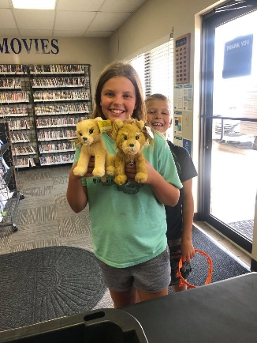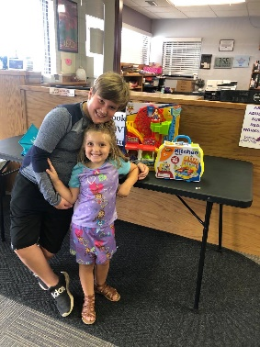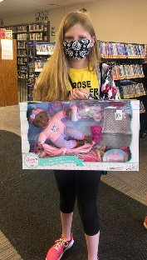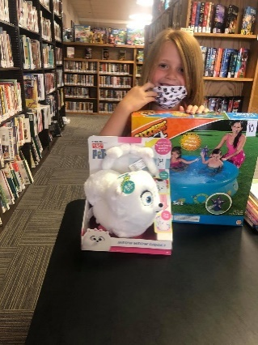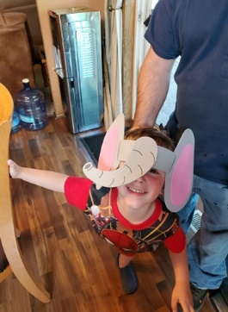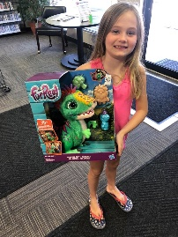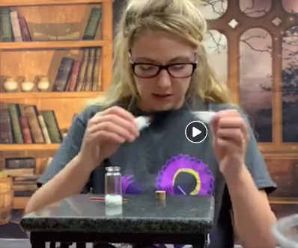

189 Children & 22 Teens Signed Up & 54 Adults Participated.

Weekly drawings were held for both the Teen and Adult Programs. Gift cards and Summer Reading Merchandise was awarded to 1st, 2nd, and 3rd place winners from each program every week.

Virtual Summer Reading Programs were offered every Wednesday at 10:30 AM on Facebook Live. Patrons could tune in and listen to live readings, participate in dancing, experiments, and interactive activities!

Every week Summer Reading Participants could come pick up crafts, small giveaway toys, worksheets, and supplies to create experiments which were shown on the Online Program.

It was estimated that about 500 patrons viewed each weekly program.

A Story Stroll was placed at the JWMS/JWHS Loop for Families to enjoy from August 3rd – 9th.