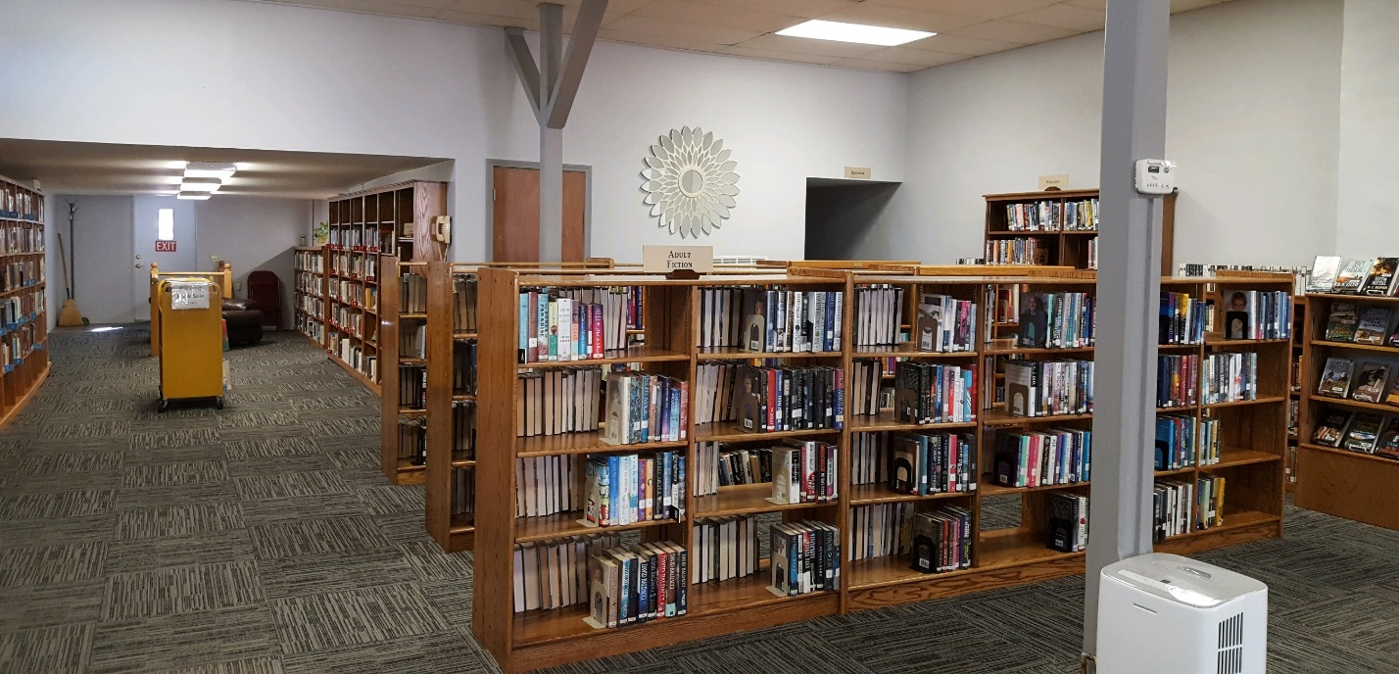
CENTRALIA COMMUNITY LIBRARY
520 4TH STREET
CENTRALIA, KS 66415
785-857-3331

Strategic Planning for 2021-2024

Vision Statement

The Centralia Community Library, a tax-supported community resource, will provide informational, educational services, materials, and programs to users of all ages.

Mission Statement

The mission of the Centralia Community Library is to provide diverse cultural opportunities for reading, learning, and entertainment to all citizens within its service area.

2021-2024 Strategic Plan

GOAL #1: Effectively market the library’s products and services.

Objective 1.1 – Enhance the awareness and presence of the Centralia Library within its own community.
Action Steps:
- Support and sponsor city and community events ie: Trick or Trunk, Card parties, coffee group, 4th of July parade, Big Kansas Road Trip.
Timeline: Year round
Responsible Parties: Library Director and Library Board

- Partner with the local school and nursing home to share books and materials.
Timeline: Year round
Responsible Parties: Library Director and Library Board

- Put an article on city’s quarterly newsletter to keep public abreast of ongoing activities and resources of the library.
Timeline: Year round
Responsible Party: Library Director

Objective 1.2 – Increase the use of media outlets to advertise library opportunities and resources.
Action Steps:
- Learn how to use WordPress to maintain our own library website.
Timeline: Beginning 2021
Responsible Party: Library Director

- Use social networking such as Facebook to promote opportunities and resources provided through the library.
Timeline: Ongoing
Responsible Party: Library Director

- Use city resources to advertise the library such as quarterly newsletter and street signage.
Timeline: Ongoing
Responsible Party: Library Director

Objective 2.2 – Continue to provide and promote activities to engage community involvement.
Action Steps:
- Maintain regular events for the community ie: coffee groups, card groups, Trunk Treats.
Timeline: Present - Ongoing
Responsible Parties: Library Director and Library Board

- Join with other groups for an activity ie: Night at the North Pole
Time line: Present – Ongoing
Responsible Parties: Library Director and Library Board

Objective 2.3 – Create a library atmosphere that will optimize the utility of the existing space and improve community interaction within it.
Action Steps:
- Discuss and prioritize ways to improve operation and physical appearance of library. Consult with NEKLS on different circulation desk.
Timeline: Ongoing
Responsible Parties: Library Director, Library Board & other

2.Investigate new technologies to improve library systems and add resources ie: Cloud key, Techsoup, Flipster, Zoom
Timeline: Ongoing
Responsible Parties: Library Director and Library Board

Goal #3: Increase and secure financial sources and non-financial resources.

Objective 3.1 – Efficiently utilize volunteers with expertise or resources.

Action Steps:
- Establish and maintain relationships with community members and patrons of the library to help the library implement/improve programs, maintain building and other improvements as needed.
Timeline: Present – ongoing
Responsible Parties: Library Director and Library Board

Objective 3.2 – Hold fundraisers to ascertain monetary resources as needed.

Action Steps:
- Participate in the Annual Library Giving Day each April with assistance from NEKLS.
Timeline: Present – Ongoing
Responsible Parties: Library Director and Library Board

- Develop a plan for ongoing fundraising activities.
Timeline: Present – Ongoing
Responsible Parties: Library Director and Library Board

Objective 3.3 – Actively research and pursue local, state and federal grant opportunities.

Action Steps:
- Establish needs and priorities of library and then research and review grant opportunities.
Timeline: Present – Ongoing
Responsible Parties: Library Director and Library Board

Goal #4: Conduct and provide relevant, timely and informative evaluation

Objective 4.1 – Evaluate the status of current programs, services, and resources offered by the library.
Action Steps:
- Continue to evaluate and develop the library’s collection
Timeline: Present – Ongoing
Responsible Party: Library Director

- Seek input from patrons and community members through conversation and comments.
Timeline: Present – Ongoing
Responsible Party: Library Director

- Continue to research, participate and evaluate library service agreements with various libraries and regional and statewide organizations to increase easy access to materials not in the library’s collection.
Timeline: Present – Ongoing
Responsible Party: Library Director

Objective 4.2 – Review all library plans (Strategic Plan and Technology Plan annually.
Action Steps:
- Create a formal procedure to establish committees and timelines
- Hold annual meetings with each committee that has a plan in place.
Timeline: Present – Ongoing
Responsible Parties: Library Director and Committee Members

- Review plans annually and determine appropriate revisions to goals, objectives, action steps, and timeline.
Timeline: Present – Ongoing
Responsible Parties: Library Director & Committee Members

- Provide updated changes and revisions to board for approval.
Timeline: Present – Ongoing
Responsible Parties: Library Director

Objective 4.3 – Evaluate and invest in staff and volunteers
Action Steps:
- Continue to conduct an annual evaluation on any staff members.
Timeline: June of each year
Responsible Parties: Library Director

- Conduct an annual evaluation of the library director.
Timeline: June of each year
Responsible Parties: Library Board

- Evaluate volunteers and offer orientation, training, tools, and resources when feasible.
Timeline: Present – Ongoing
Responsible Parties: Library Director and Library Board

Board Approved 8/17/2020

